Step 1. Initial Value

param FCRTR=0.1, FCATR=50

Step 2. 1 parameter bifurcation

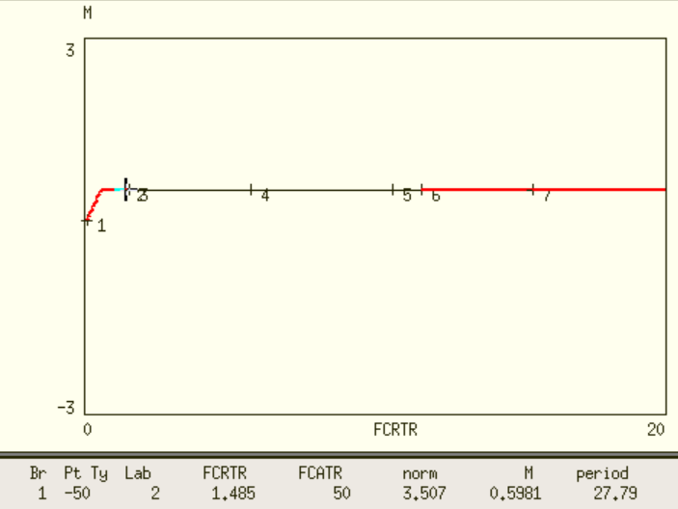

Step 3. Grab HB points and plot 2 parameter bifurcation